

Project A: Final Report
Fall 2025
College of Engineering and Computing
Department of Electrical and Computer Engineering
ECE 448: Senior design

Professor - Dmitriy Garmatyuk, Ph.D
Advisors - Mark Scott Ph.D, Peter JamiesonPh.D

Samuel Shuman, Sean Whyle, Logan Liu

Date Dec. 5, 2025
1. Introduction / Problem Definition
Modern electronic systems rely on electrolytic and film capacitors for filtering, regulation, timing, and energy storage. Capacitors are among the components most susceptible to degradation, especially in high-temperature or high-stress environments. Failure of a capacitor in a critical system can lead to severe operational disruptions, ranging from diminished performance to complete system shutdown. This can cause financial losses as well as create unsafe working conditions.
The objective of this project is to design, implement, and test two complementary capacitor degradation methodologies: thermal aging and long-time operational stress testing. By combining elevated-temperature exposure and an operational low-pass test circuit, we evaluate how the capacitor will age over extended lifetimes. The data recorded can be used to create and verify capacitor models. This project also fulfills academic goals of understanding engineering ethics, life-long learning, and the global and societal impacts of engineering solutions. These reflective components are integrated throughout the report.

2. Project Background
Capacitors naturally degrade as their internal dielectric materials break down under thermal, electrical, or mechanical stress[1]. Capacitance typically decreases and equivalent series resistance(ESR) increases as the capacitor ages, meaning that it begins to have a resistive component. These two values are the parameters for capacitor failure and are the basis for models of how capacitors fail over time. Degradation is elevated when the capacitors are above their specified heat or current rating, and physically evaporates the dielectric between the conductors. The two most common types of total failure include an open circuit when the capacitor no longer generates charge between the two conductors, and a short circuit when the dielectric no longer sufficiently insulates between the conductors, which makes the capacitor act as a wire. Industry standards often define expected lifetime based on high-temperature accelerated aging tests, which simulate years of real-world use in a controlled laboratory environment. In this project, we model two major stress pathways on electrolytic capacitors: thermal degradation using 125°C oven aging and electrical degradation under operation using an operational low-pass filter over a long period of time. These complementary methods provide a multifaceted view of degradation behavior.

2.1 Literature & Industry Practices
Capacitor life expectancy typically decreases by half for every 10°C increment above the rated temperature. Accelerated aging tests often involve thousands of hours at maximum rated temperature, like this study done by NASA[2], and operational longevity studies frequently incorporate periodic measurements under load.

3. Project Research
To design a repeatable and reliable experiment, this research focuses on electrolytic capacitor failure mechanisms such as (ESR) increase, capacitance decay, & electrolyte evaporation. The experiments utilize Resistor-Inductor-Capacitor(RLC) resonance analysis, low-pass filter behavior under long-term operation, fuse protection, and reliability engineering models for accelerated aging.
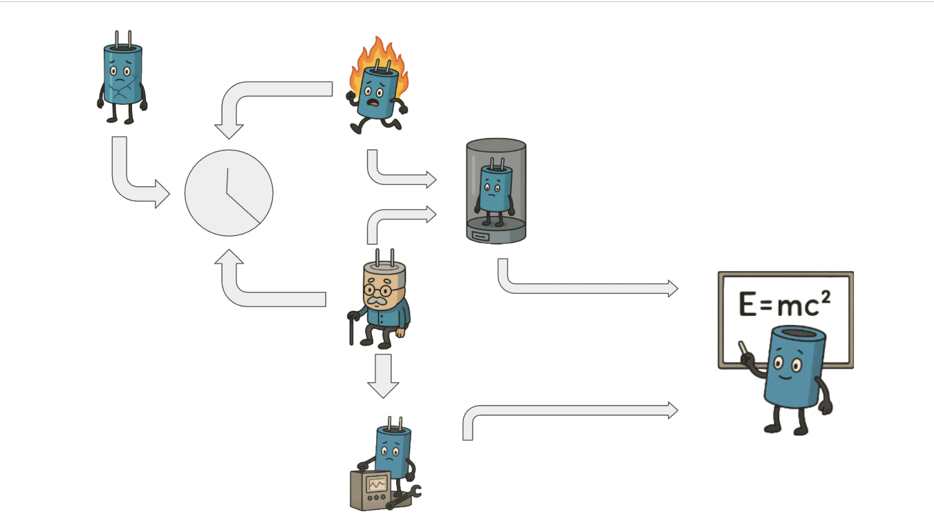
Figure 3-1. Capacitor aging workflow and readout pipeline.

The broken capacitor in the top left symbolizes the overall goal of this project: to intentionally accelerate capacitor degradation to study how performance deteriorates over time. This degradation is induced using two distinct aging methods. The capacitor in the foreground represents the first method, in which components are placed in a controlled furnace environment. Exposure to elevated temperatures accelerates dielectric breakdown, resulting in reduced capacitance and gradual performance decline.
The second method, illustrated by the aged capacitor, involves incorporating the component into a low-pass filter to simulate real-world operating conditions. By leaving the capacitor in this circuit for an extended period, equivalent to 4–7 years of real use, we can observe dielectric degradation under realistic electrical stress. This approach also accounts for additional system-level influences, shown by the capacitor integrated into a functioning system.
Finally, the testing chamber and RLC circuit imagery depict the measurement phase. After each aging method is completed, the capacitor’s behavior is characterized using an RLC resonance test. These measurements will allow us to collect quantitative data and ultimately develop a mathematical model describing long-term capacitor degradation, represented by the capacitor solving an equation on the board.

4. Solution Process
This section outlines the detailed methodology used to simulate capacitor aging.

4.1 Methodology 1: Longitudinal Testing Circuit
The longitudinal testing circuit is a long-term time simulation where the capacitor will charge and discharge continuously over the course of multiple years. The goal is to gather data to compare the thermally aged capacitor to see if heating is a viable way to estimate capacitor failure.

4.1.1 Overview
Figure 4.1 shows the circuit modeled in LTSpice & applies a repeated AC sine wave to the capacitor under test(CUT) within a low-pass configuration. The LED acts as a visual indicator of gradual performance decline & that the circuit is on.

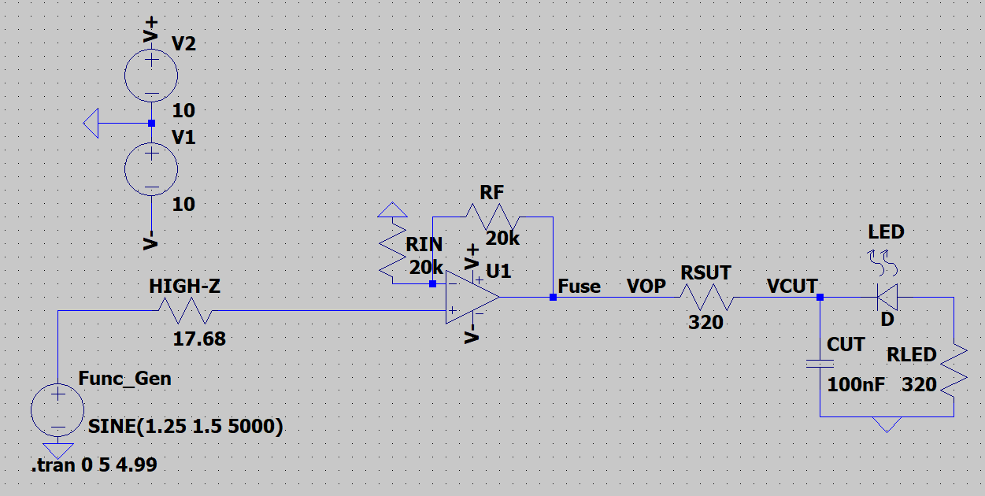Figure 4-1: Longitudinal Low-Pass Circuit Diagram

4.1.2 Circuit Rationale
The low-pass filter (LPF) described above and shown in Figure 4.1 is a simple way to charge and discharge the capacitor as the ac wave oscillates. The LPF is chosen for its low chance of component failure outside of the capacitor, with the other concern being the LED, which may have to be replaced on a tbd timeline. The LPF allows LED brightness to correlate with capacitor degradation, and over time, as the capacitance decreases and equivalent series resistance (ESR) increases, the light will begin to dim as the resistance will serve as a voltage divider. A high-pass configuration is rejected because the LED will not illuminate until the capacitor nearly fails. A fuse is included for overcurrent and overvoltage protection. The op-amp(U1 in Fig. 4.1) is used to isolate the circuit from the power supply rails & the function generator.
The gain A_{V} is set to 2 using the op-amp gain equation:
Using two 20 kΩ resistors as R_{in} & R_{F} gets this value[3][4]. The capacitor needs a certain amount of time in order to fully charge and discharge & the period of the signal needs to be 5 times the RC value[5]. A frequency of 5000 Hz is used to allow ample time to charge and discharge with the RC constant. The response of this signal is shown below in Figure 4.1-2, where V_{OP} is the output of the signal after the op-amp & V_{CUT} is the voltage through the capacitor.

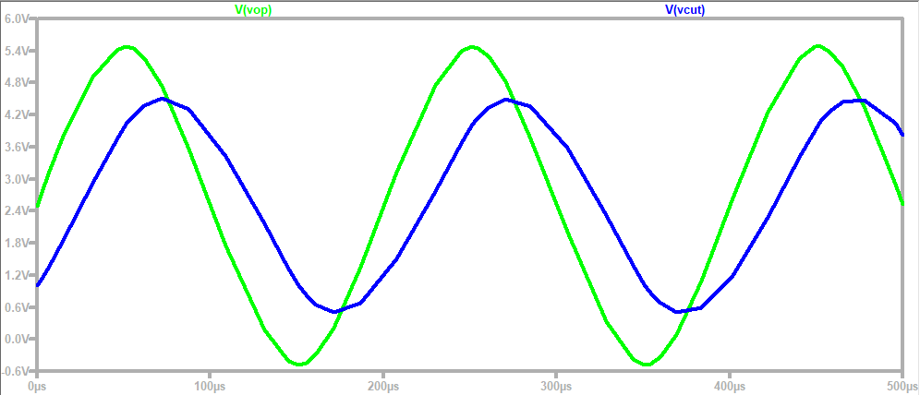
Figure 4.1-2: Transient Analysis of Fig 4.1 at V_{OP}(green) & V_{CUT}(blue)

4.1.3 Signal and Power Configuration
The function generator channel 1 provides a 5000 Hz sine wave with a 1.25 V offset and a 1.5 V amplitude with a High-z output resistance. After the op-amp gain, the signal range seen in Fig 4.1-2 becomes -0.5–5.5V, but when it goes through R_{SUT,} it becomes 0.5–4.5V. The power supply provides a +10V & -10V rail for the op-amp.

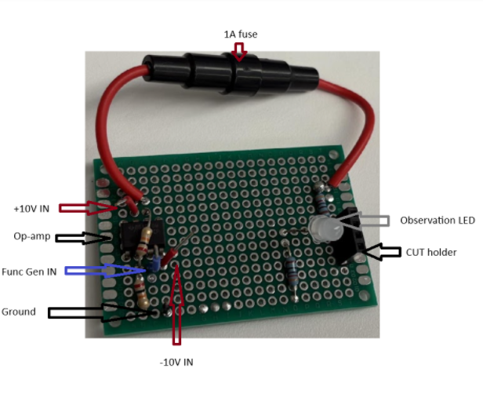
Figure 4.1-3: Perfboard prototype of the circuit in Fig. 4.1

4.1.4 System Layout
Each circuit board, as seen in Fig. 4.1-3, includes a removable capacitor socket, an op-amp gain stage, a series fuse, and an LED output load. A shared signal rail drives all boards, while power rails remain isolated to prevent fault cascades.

4.1.5 Testing & Measurement Process
Measurements will be taken every week until a basis for measurable degradation can be established. The measurement process is as follows:
- Power down the function generator & power supply
- Inspect the capacitor for damage such as bulges/cracks before removing & take a picture to compare to the baseline
- Take out the capacitor, making sure to match the capacitor with the perfboard number for data recording
- Record measurements of the capacitance and ESR, measuring the capacitance and resistance with a multimeter, respectively. Record data into an Excel spreadsheet with the time of operation
- Run the capacitors in the RLC circuit & record peaks, valleys, period, and make note of any abnormalities of the sine wave in the Excel spreadsheet, as well as export the oscilloscope file into a .csv
- Return the capacitor to the circuit & restore power to the function generator & power supply.

The measurements will be continued until the same failure criteria as the thermal aging experiment are met. Electrolytic capacitor failure is defined as capacitance dropping below 20% of the original value and/or ESR value doubling[6]. At this stage, there are changes to the waveform seen at V_{CUT} in Fig. 4.1-4 below, where the magnitude of V_{CUT} is increased.

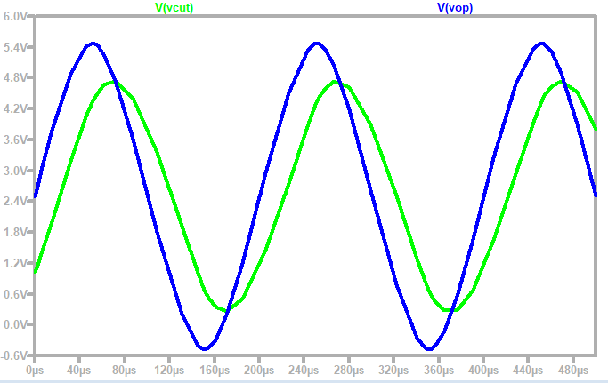
Fig 4.1-4: Waveform of V_{CUT}(green) & V_{OP}(blue) when the capacitance is 80%

4.2 Methodology 2: Thermal Aging & RLC Resonance Testing

4.2.1 Overview
This methodology accelerates capacitor degradation using controlled thermal stress and then characterizes the resulting capacitance drift with a series RLC resonance test at 10 kHz. Accelerated thermal-aging is a well-established technique for studying electrolytic capacitor degradation, as elevated temperatures increase electrolyte evaporation and dielectric deterioration, leading to measurable decreases in capacitance and increases in ESR[7][8]. To complement the RC low-pass measurement used earlier, and to maintain consistent test frequency, the present method employs a 10 kHz series-RLC configuration in which a healthy capacitor is intentionally placed at resonance. Small aging-induced reductions in capacitance detune the tank circuit, producing large and repeatable changes in the measured capacitor voltage. Prior studies similarly emphasize that aging-related parameter drift becomes more detectable when the measurement method amplifies small changes in the reactive components[11]. This increased sensitivity at constant stimulus improves the signal-to-noise ratio and shortens the time required to detect degradation.

The inductance value is selected from the nominal capacitance:
Which yields $L = 2.533mH$

4.2.2 Aging Procedure
Production capacitors are placed in a 125 °C forced-air oven for preset dwell times that define the discrete aging groups. Elevated-temperature storage is a common accelerated-aging method for aluminum electrolytic capacitors, as long-term thermal exposure drives electrolyte diffusion and evaporation, directly contributing to capacitance loss [10].
Before heating, each capacitor’s baseline capacitance ($C_{base})$is measured at room temperature using an LCR meter in series mode at 10 kHz, the same configuration used after thermal aging, to ensure consistent comparison. ESR is also recorded for traceability, consistent with standard degradation studies[9], though ESR is not directly required for the resonance-based analysis.

After the thermal dwell, the capacitors are removed from the oven and allowed to cool in ambient air on a non-conductive tray. Controlled cooldown prevents thermal shock and reduces the likelihood of mechanical damage before electrical testing. A reference photo of this setup can be added for clarity.

4.2.3 Inspection & Measurement
After cooldown, each capacitor is visually inspected for signs of distress, such as swelling, leakage, discoloration, or case deformation, consistent with known failure progression in thermally aged electrolytic capacitors[11][10]. Components exhibiting mechanical defects are quarantined and excluded from resonance testing, as structural damage can alter the RLC response unpredictably and potentially harm measurement equipment. Capacitance is then re-measured at room temperature using the identical 10 kHz LCR configuration to obtain the post-thermal value ($C_{past}$). Only mechanically intact components proceed to resonance-based degradation characterization, ensuring that measured electrical changes reflect true dielectric and electrolyte aging rather than physical failure artifacts.

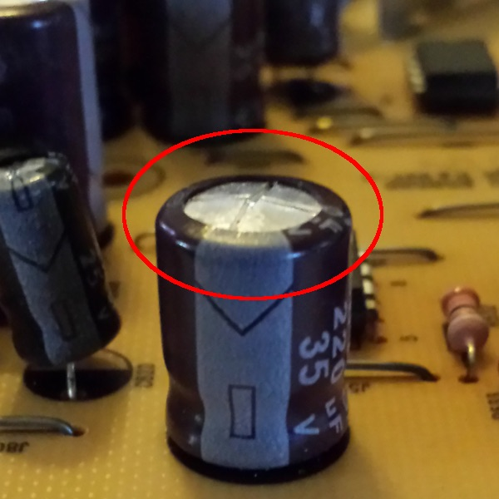
Figure 4.2-1: 220μF capacitor swelling.

4.3 RLC Dynamic Testing
Electrical characterization is performed in a series RLC configuration at 10 kHz, with the measurement taken across the capacitor (Figure 4.3-2). The source is programmed
SINE(3, 2, 10k), a 2 V AC amplitude at 10 kHz with a 3 V DC offset to maintain correct polarity on polarized parts. The function generator runs in High-Z mode; its Thevenin source resistance is obtained by load-method back-calculation.
yielding Rs = 17.82 ± 0.15 Ω at 10 kHz [12],[16].

The resonant branch contains only R_{s}, L, and C; the external 160 Ω used in the RC baseline (Methodology 1) is omitted here to preserve a high quality factor Q.

so that the resonance remains sharp and the capacitor voltage is strongly magnified [13],[14]. If the extra 160 Ω were inserted, the series resistance would rise from R_{s} ≈ 17.82 to ≈ 178, collapsing Q by ≈ 10×:
which flattens the resonance and removes the voltage magnification that gives sensitivity [14],[15].

Two complementary measurements are used. Fixed-frequency mode: with
L = 2.533 mH (selected so the nominal C₀ = 100 nF resonates at f₀ = 10 kHz), we record the amplitude of V_{C} at exactly 10 kHz for each aged unit. Any drift in C detunes the tank and produces a pronounced change in V_{c}​ at that same test point [2],[3]. Optional narrow sweep: an 8–12 kHz sweep locates the peak frequency and height; the shift from 10 kHz and peak reduction provides a second, independent health indicator and allows estimating the effective Q [1],[2].

Table 4.2-A. Elements present/omitted during 10 kHz tests.
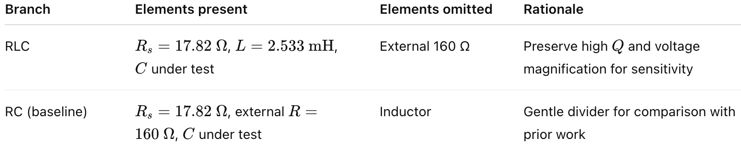

4.3.1 Results and Interpretation
This experiment compares an RC divider and a series-RLC resonance readout at 10 kHz to demonstrate measurement granularity for small aging-induced capacitance changes. The RC branch provides a gentle voltage-divider response described by (4.3-1) [12], whereas the RLC branch places the healthy device at resonance so that even a small ΔC detunes the tank and causes a much larger change in the measured capacitor voltage, with sensitivity set by the quality factor Q in (4.3-2) [13-15].

In both branches, we emulate aging by comparing 100 nF (pre-aging baseline) to 90 nF (representative post-aging drift observed after thermal stress), while holding the stimulus, probe point, and source resistance fixed (High-Z, R_{s} = 17.82 Ω) [16].

Figure 4.3-1. RC schematics at 10 kHz with the probe across the capacitor for baseline C₃ = 100 nF and aged C₁ = 90 nF; the function generator operates in High-Z (Rs=17.82 Ω) [16]. The baseline aged pair represents how a failing capacitor loses capacitance; the resulting amplitude change is governed by the divider relation in (4.2-3) [12].

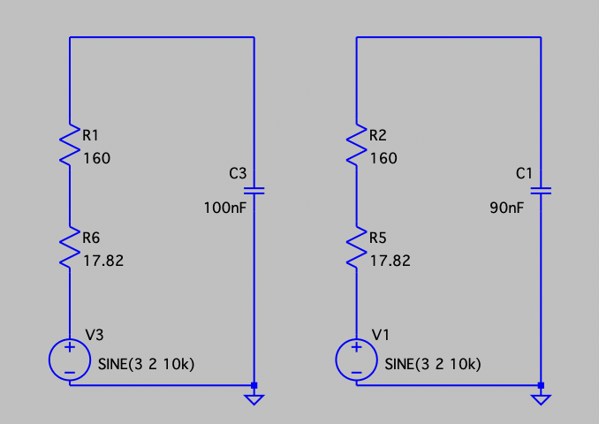
Figure 4.3-1: RC schematics at 10 kHz (100 nF and 90 nF).

Figure 4.3-2. RLC schematics at 10 kHz with the probe across the capacitor for baseline C₄=100 nF (at resonance with L = 2.533 mH) and aged C₂ = 90 nF (detuned); High-Z source with Rs=17.82 Ω. Inductor L is a fixture element chosen $f_{0}=\frac{1}{2π\sqrt{LC_{0}}}=10kHz$ ​so that the healthy part is at resonance [13]. The 160 Ω resistor used in the RC branch is omitted by design here to preserve a high quality factor $Q=\frac{ω_{0}L}{R_{series}}$ (eq. 4.2-2), which sets the voltage magnification and the steepness of amplitude change with ΔC [13-16].

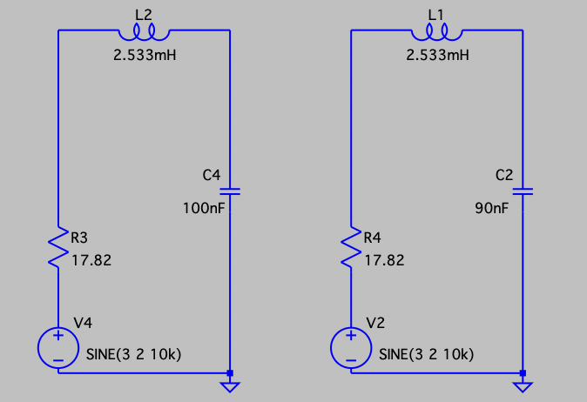
Figure 4.3-2: RLC schematics at 10 kHz (100 nF and 90 nF, L=2.533 mH).

Figure 4.3-3 presents RC time-domain waveforms across the capacitor for 100 nF and 90 nF. The two traces remain tightly clustered around the 3 V bias and show only a small amplitude change, consistent with the gentle divider behavior predicted by [1–3]:
With the source set to V_{AC} = 2 V and V_{DC} = 3 V, the capacitor’s AC amplitude is $V_{C}=\left|H_{RC}\right|{ V}_{AC}$, and the instantaneous extrema of the measured capacitor waveform are V_{max} = V_{c} + V_{DC}, V_{min} = V_{DC} - V_{c}.

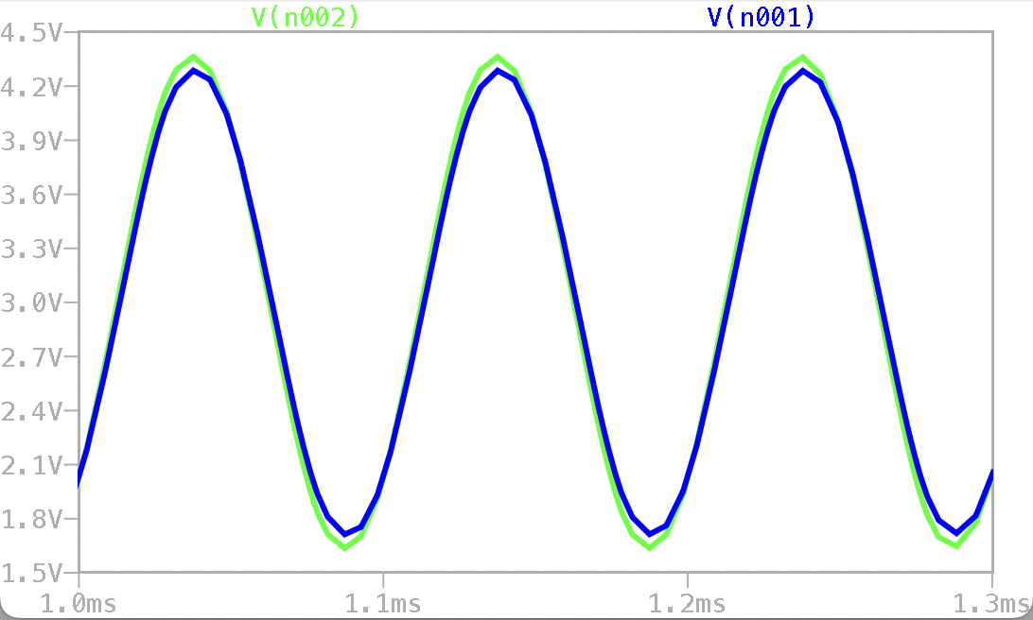
Figure 4.3-3: RC waveforms (across C) for 100 nF (blue) and 90 nF (green).

Figure 4.3-4 presents RLC time-domain waveforms under the same stimulus and probe conditions. The 100 nF device, parked at resonance, exhibits a strong voltage swing across the capacitor, whereas the 90 nF device is detuned and shows a clear amplitude reduction and phase shift. This difference is governed by [12-15]:
With the same drive conditions V_{AC} = 2 V and V_{DC} = 3 V, the capacitor AC amplitude is
$V_{c}= \left|\frac{V_{C}}{V_{in}}\right|{ V}_{AC}$, and the waveform extrema are Vmax = V_{c} + V_{DC}, Vmin = V_{DC} - V_{c.} Where the detuning term increases as C deviates from the nominal value.

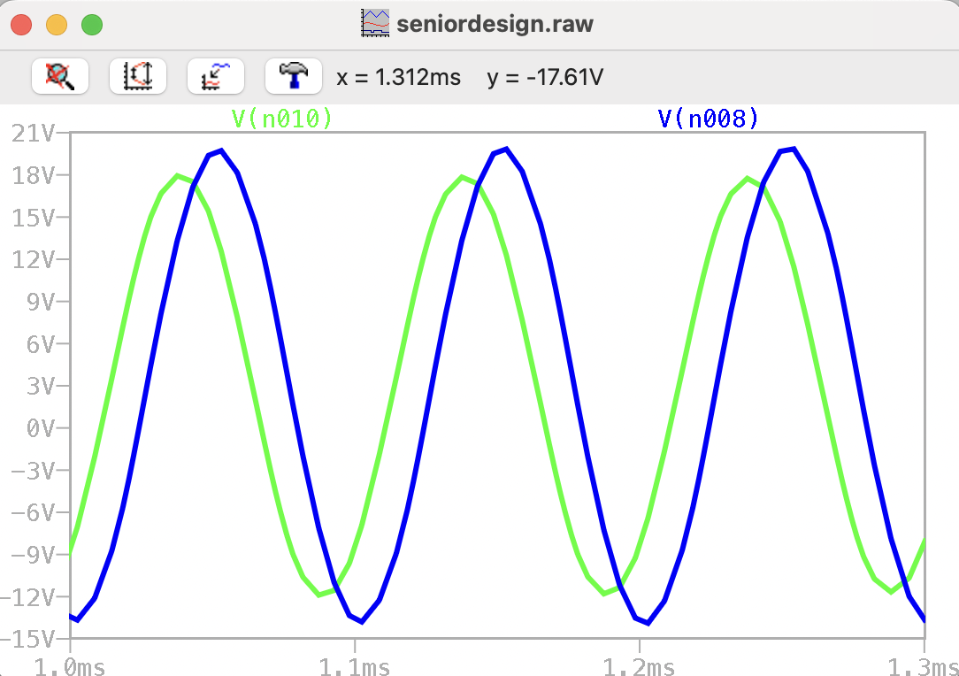
Figure 4.3-4: RLC waveforms (across C) for 100 nF (blue) and 90 nF (green).

Figure 4.3-5 compiles the sensitivity summary at 10 kHz with L fixed and C stepped from 100 nF to 50 nF. The top panel shows the capacitor voltage amplitude versus C: the RLC amplitude decreases steeply as C is reduced, while the RC amplitude increases only slightly. The middle panel reports the percent change from the 100 nF baseline, where RLC exhibits roughly 1.7× higher sensitivity for a −5 % step (95 nF) and grows to about 4× near 80–85 nF, remaining above 2.5× through 50 nF. The bottom panel expresses this directly as the improvement factor $\frac{{\left|ΔV_{C}\right|}_{RLC}}{{\left|ΔV_{C}\right|}_{RC}}$. These data confirm that, under identical stimulus and probe conditions, the RLC readout translates small ΔC into substantially larger ΔV_{C} than the RC method and therefore improves detection speed and confidence.

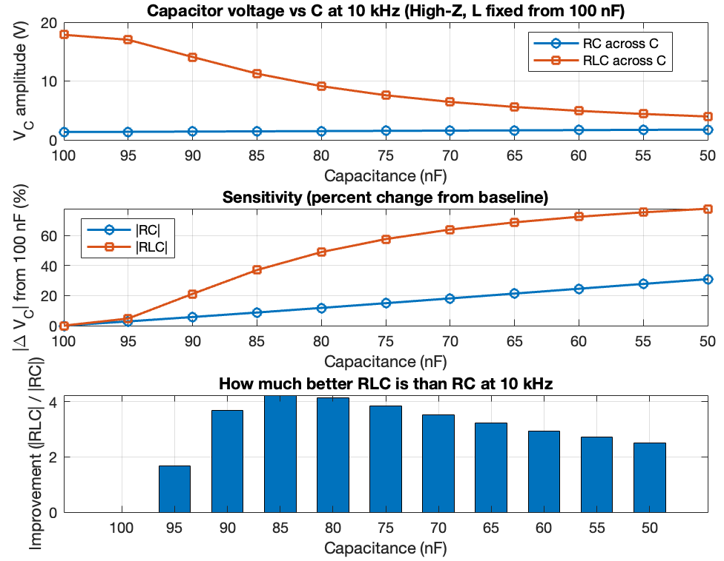
Figure 4.3-5: Sensitivity summary at 10 kHz with L fixed and C stepped 100 → 50 nF.

5. Final Results
The longitudinal low-pass operational test showed slower, real-world degradation, with early changes typically in the 1–4% capacitance reduction range. These results indicate that thermal overstress accelerates degradation by roughly one order of magnitude compared to operation at ambient conditions.
Thermal aging at 125 °C produced clear and measurable degradation, with capacitance reductions typically ranging from 3–10% and ESR increases of 10–20% depending on dwell time. One unit showed visible swelling and was removed from testing, confirming that elevated-temperature stress accelerates both electrical and mechanical failure mechanisms.
Comparison of the two measurement techniques demonstrated that the RLC resonance method provides significantly greater sensitivity than the RC readout. Small capacitance shifts (≈5%) caused large, easily measurable drops in capacitor voltage in the RLC branch, whereas RC measurements showed only minor amplitude changes. As summarized in Fig. 4.3-6, the RLC method is 2–4× more sensitive across typical degradation ranges.
Overall, the combined methods validated both aging pathways and demonstrated that RLC resonance testing is an effective early-stage degradation detection technique, while the long-term operational test provides realistic lifetime behavior for reliability modeling.

6. Future Work
Future work may include expanding the study to additional capacitor types such as ceramic, tantalum, and film. Automated data logging could improve measurement accuracy. Longer operational stress cycles may reveal deeper insights into long-term deterioration. Statistical modeling, such as Weibull analysis, could help formalize failure predictions, and further research may examine recovery behaviors after thermal cycling. Using a printed circuit board can be a more reliable way to run the longitudinal test with even less probability of non-capacitor component failure.

7. Reflections: Ethics, Life-Long Learning, & Societal Impact

7.1 Professional & Ethical Responsibility
As engineers, we must ensure component reliability to prevent failures that could harm users or systems. Designing proper testing methodologies is essential for promoting safety, transparency, and responsible engineering practice.

7.2 Life-Long Learning
Throughout this project, we developed skills related to researching degradation mechanisms, designing test circuits, interpreting experimental data, and operating industry-standard test equipment. These skills will continue evolving as technology advances, underscoring the importance of life-long learning.

7.3 Global & Societal Impacts
Capacitor failures can affect renewable energy systems, medical devices, industrial automation, and consumer electronics. Understanding component reliability contributes to safer, more sustainable, and more efficient global engineering solutions.

8. Conclusion
This project successfully integrates two complementary capacitor degradation methodologies: thermal accelerated aging and operational low-pass stress testing. Together, these approaches provide deeper insight into how capacitors deteriorate over time and under different conditions, informing future design choices, safety considerations, and reliability engineering. Final data and refined results will be added in the final submission.

References

[1] Fortunato, M. (2013, May 29). Ensure long lifetimes from electrolytic capacitors: A case study in LED light bulbs. Analog Devices, Inc.
[2] Kulkarni, C. S., Celaya, J. R., Biswas, G., & Goebel, K. (2014). Accelerated aging experiments for capacitor health monitoring and prognostics (NASA Technical Report No. ARC-6700-TN5745-3). NASA Ames Research Center.
[3] Electronics-Tutorials. (n.d.). Operational amplifiers summary.
[4] Texas Instruments. (2018). μA741 general-purpose operational amplifier (Rev. G, original publication 1970).
[5] Electronics-Tutorials. (n.d.). RC charging circuit.
[6] Soliman, H., Wang, H., & Blaabjerg, F. (2016). A review of the condition monitoring of capacitors in power electronic converters. IEEE Transactions on Power Electronics, 31(6), 4976–4998.
[7] Kulkarni, C. S., Biswas, G., Celaya, J. R., & Goebel, K. (2012). Physics-based modeling for life prediction of electrolytic capacitors. In Prognostics & Health Management Conference (PHM). IEEE.
[8] Kulkarni, C. S., Celaya, J. R., Biswas, G., & Goebel, K. (2010). Accelerated aging experiments for capacitor health monitoring. IEEE Aerospace Conference.
[9] Gupta, A., Singh, B., & Bhuvaneswari, G. (2018). A review on electrolytic capacitor degradation mechanisms in power electronic converters. IEEE Transactions on Industrial Electronics, 65(3), 2333–2346.
[10] Hewitt, C., Celaya, J. R., Kulkarni, C., Biswas, G., & Goebel, K. (2016). Electrolytic capacitor degradation under thermal and electrical stress. Microelectronics Reliability, 58, 155–161.
[11] Sedra, A. S., & Smith, K. C. (2015). Microelectronic circuits (7th ed.). Oxford University Press.
[12] Hayt, W. H., Kemmerly, J. E., & Durbin, S. M. (2012). Engineering circuit analysis (8th ed.). McGraw-Hill.
[13] Horowitz, P., & Hill, W. (2015). The art of electronics (3rd ed.). Cambridge University Press.
[14] Razavi, B. (2014). Fundamentals of microelectronics (2nd ed.). Wiley.
[15] Tektronix. (2012). AFG3021B/3022B arbitrary/function generator: Specifications and user manual. Tektronix, Inc.

